**InternationalRelations.org** is website dedicated to explaining international relations and all of its facets, and to educating students, scholars, as well as policymakers and practitioners on international relations. We offer in depth writing and analysis on all international topics and current events.

**International Relations** is the study of how the different actors of the international community interact with one another on a daily basis. While the scholars of international relations have traditionally examined inter-state relations, the field covers a broad spectrum of political action among the different entities at different levels of analysis.

**“INTERNATIONALRELATIONS.ORG IS A GREAT SITE FOR THOSE LOOKING TO LEARN ABOUT GLOBAL AFFAIRS.”**

We are committed to offering up to date content and analysis on current affairs, using reliable sources. Our readership is in the thousands per month, and growing rapidly. We have also been cited and linked to university and world-renowned libraries.

We cover a number of topics that include academic discussions on human rights, conflict, diplomacy, environmental issues, foreign policies, international political economy, as well as regional issues.

*www.InternationalRelations.org*

About InternationalRelations.org

International Relations

NEW VISITORS (MONTHLY)

Dr. Fait Muedini

Frances Shera Professor of International Studies

Fra

+ EDUCATION/POST-SECONDAY

+ NEWS AND CURRENT EVENTS

+ EDUCATION PREP&TUTORING

+ POLITICS

+ BOOKS AND READING

+ EMPLOYMENT

+ TECHNOLOGY

+ ARTS, TELEVISION AND MOVIES

MONTHLY PAGEVIEWS

SIDEBAR AD   
200×200

LEADERBOARD   
728×90

SKYSCRAPER  
120×600

ABOUT

DR. FAIT

MUEDINI

+

AGES 18-34

$300

$250

$100

“

”

FEMALE

58%

78.1%

88.1%

AD RATES

LINKED ON THE FOLLOWING SITES

READER INTERESTS

30K+

BLOG STATISTICS

Dr. Fait Muedini is the Frances Shera Fessler Professor of International Studies at Butler University. He has written two books (*Sponsoring Sufism: How Governments Promote Mystical Islam in Domestic and Foreign Policies,* and *Human Rights and Universal Child Primary Education)*, and numerous academic articles on human rights, and also Middle East Politics.

The Syrian Conflict

Environmental Issues

The United Nations

Libyan Civil War

[*Click Here to View*](http://internationalrelations.org/the-syrian-conflict/)

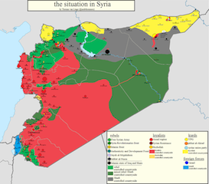



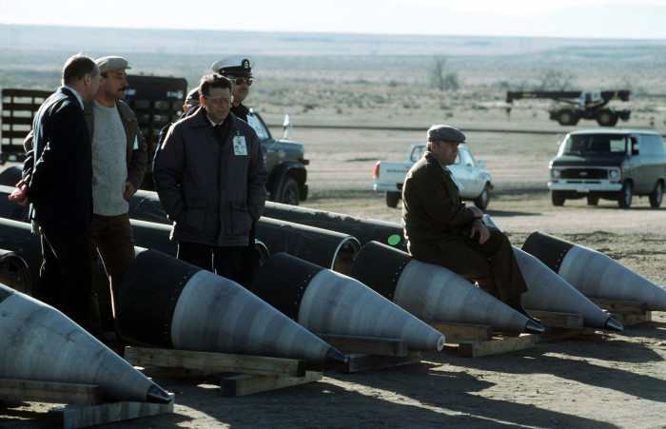

[*Click Here to View*](http://internationalrelations.org/the-united-nations/)

[*Click Here to View*](http://internationalrelations.org/environmental-issues/)

[*Click Here to View*](http://internationalrelations.org/globalization/)

[*Click Here to View*](http://internationalrelations.org/libyan-civil-war/)

[*Click Here to View*](http://internationalrelations.org/nuclear-weapons/)

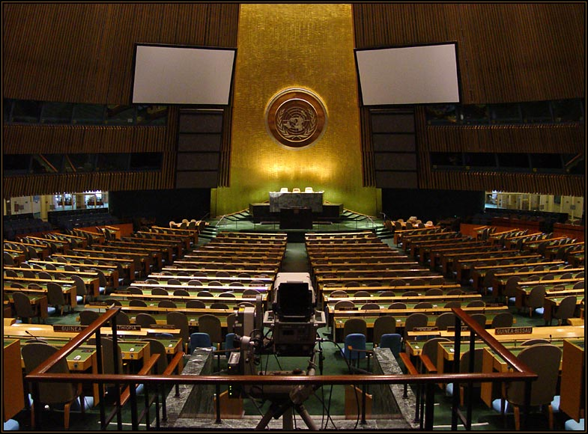

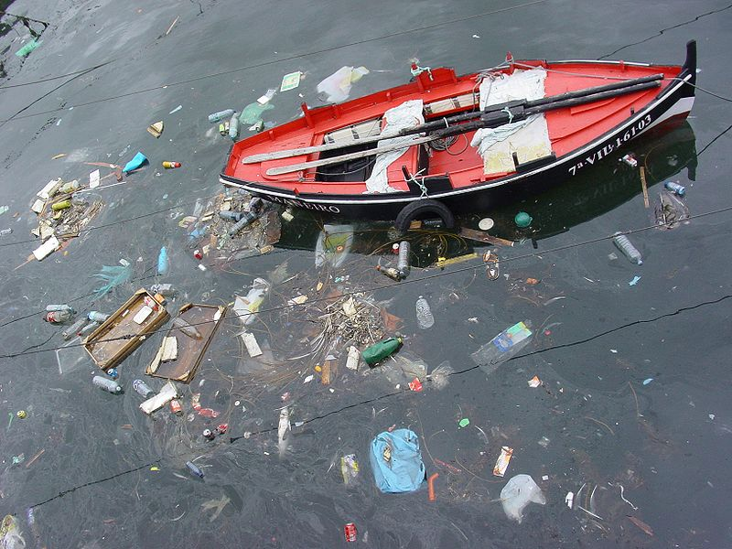

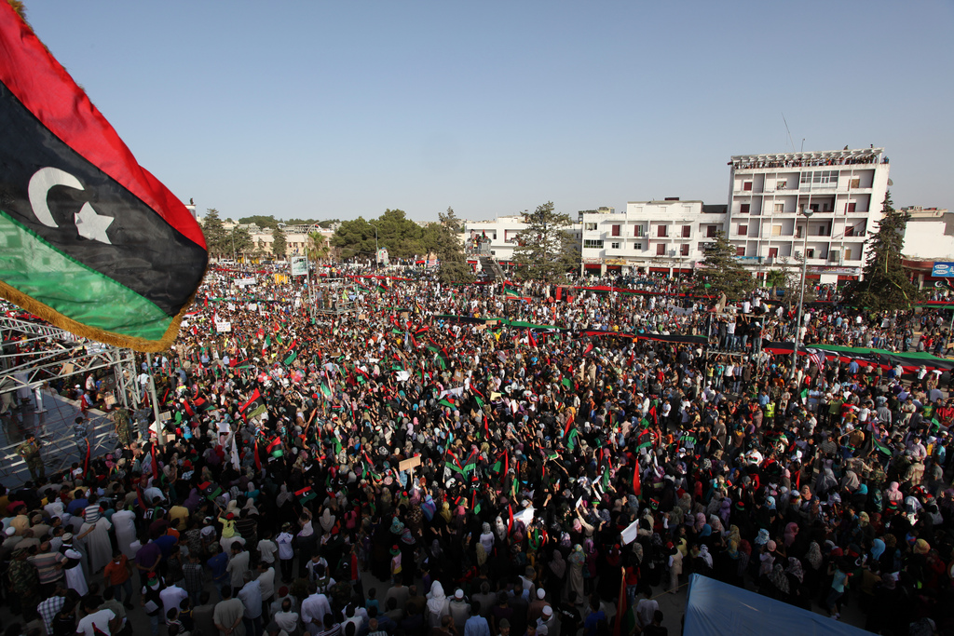

Globalization

POPULAR TOPICS

Nuclear Weapons

*fmuedini@butler.edu*

[*www.internationalrelations.org*](http://www.yourblogname.com)

1 [*+1*](http://www.yourblogname.com) *734 624 3878*

*Fait Muedini, Ph.D.*

LET’S WORK TOGETHER!